„...I take pleasure in my weaknesses and in the insults, hardships, persecutions, and troubles that I suffer for Christ. For when I am weak, then I am strong.”
2Cor 12:10 (NLT)

2019. 05. 08.

Newsletter of the Barnabas Foundation

Thanksgiving
Praise God for how our work is unfolding in Szekelyudvarhely! Piroska Lisztes, local music teacher has taken on a substantial part of our organisation’s work, becoming one of our employees. Her wage is being covered mostly by the funds coming in through the children she is teaching, except for the summer months when schools are closed. During this time, she helps out with organising the camps at the Barnabas House. In March the children she is teaching put on a wonderful concert for their peers with different abilities and their families. The concert took place in the Baptist Church of Szekelyudvarhely. Praise the Lord for the local support group that is now there to help people with different abilities, and for Piroska who truly is an answer to our prayers!
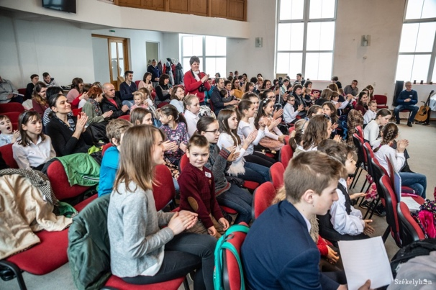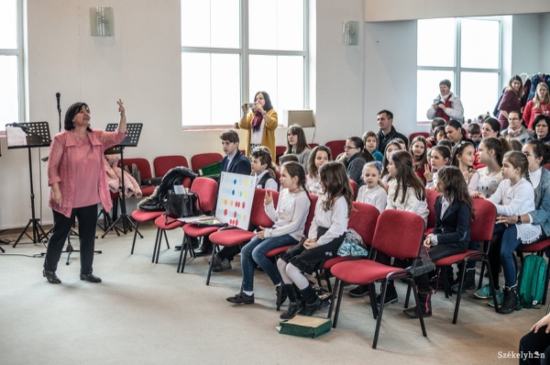
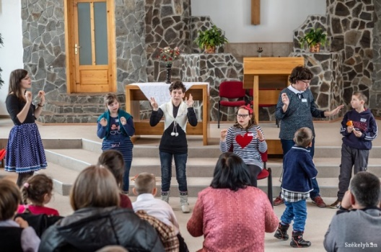
„If you remain in me and my words remain in you, ask whatever you wish, and it will be done for you.”
John 15:7 (NIV)

Prayer Requests

Renovation works
We would like to finish renovating the outside of the Barnabas House by June. We are putting stairs to the attic, so it would be accessible from the terrace area. For now, it is the camp leaders who would be using the attic which, once fully renovated, could be a place to stay for the leaders’ families during camp weeks. A big thank you for the support of Christina Büchi (Swiss) and her congregation’s mission support in this way, too!
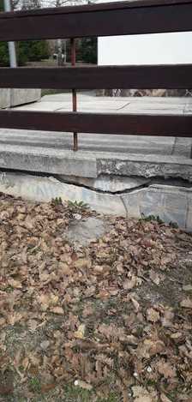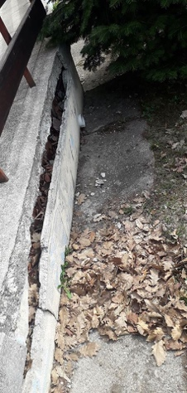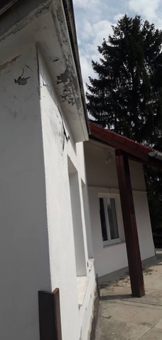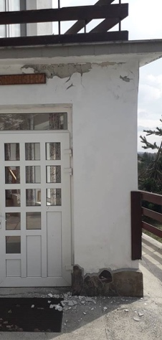

Hope Conference
Let’s pray for this year’s big gathering! Individuals from all over the country with different physical abilities will be coming together, mostly adults who have been participants of the camps at the Barnabas House. The organisers of the conference are Otto Kiss and Sandor Kelemen from Marosvasarhely. Piroska Lisztes will also be partaking as a representative of our foundation’s leadership.
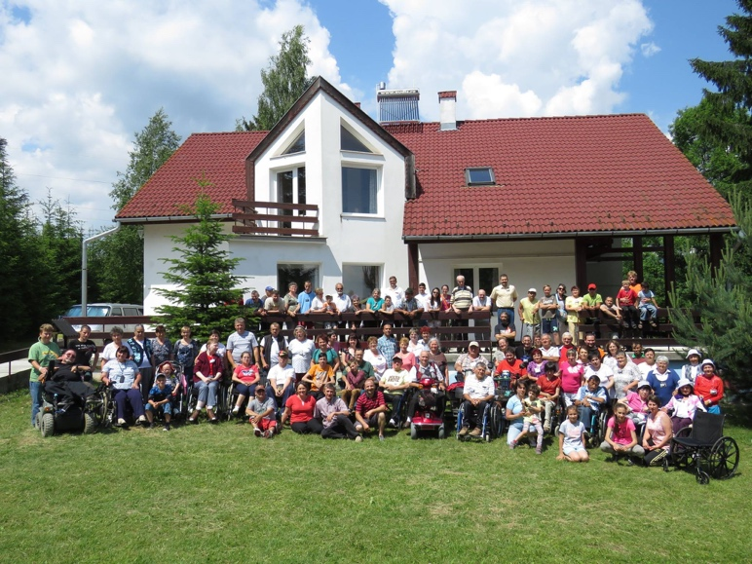
Special tea room
Thank God that many groups keep meeting up called special tea room in several different places following our camps, mostly in churches. Let’s pray for the Children’s Day in June that will be celebrated in Zilah this year, with events and activities planned for little ones with different abilities and their families.
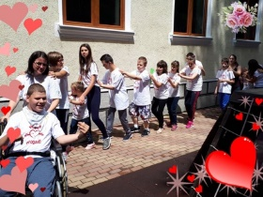

Summer Camps 2019
This year one of our greatest dreams is coming true as our four children’s camps (from the areas of Szilagysag, Kolozsvar, Szekelyfold and Bihar) will be happening together as one big event! We are grateful for our friends from Switzerland (Christlike Ostmission) who are funding this project. More than one hundred of us campers (children, families and leaders) will be going to Hungary, accepting an invitation from the Revay Gyorgy special needs school in Tiszafoldvar.
Most of the campers are from non-Christian backgrounds; they are in need of evangelism, of comfort from Christ. Let’s pray for suitable volunteers who will be able to help us organise everything properly.
Let’s also pray for the directors of the above-mentioned institution, as we would like to establish partnership with them. We believe that they will also be able to come and camp at the Barnabas House in the future - this way we can mutually encourage and strengthen each other in the work we both are doing.
The camp for individuals with different physical abilities run by Jony and Friends will be happening again this year at the Hargita Christian Camp, and thus at the Barnabas House. In addition, during the yearly youth week at the Camp those with different abilities will be staying in the house; our aim is to enable them to partake in all of the major activities. Their participation is also being covered by the foundation, as they are unable to support themselves in this way; due to numerous medical treatments and other expenses they do not have the financial capacity for anything other than fulfilling basic needs. Let’s pray that many of them will come to faith in Jesus during these camps!
Traditionally, the senior citizens and the group from Marosvasarhely will also be camping at the Barnabas House. The organisers of these two camps have managed to acquire funding for each week. We are thankful that they thought of our foundation when giving!
Our prayer is that each summer gathering and camp week will fully serve God’s glory and that many would come to know Jesus as their personal Saviour!

Thank you very much for all of your prayers!
Regards and lots of love in the name of our foundation:
Evodia Budai
CEO

Barnabás Foundation
Vlahita, str. Ciucului nr.106
Hargita Christian Centre
tel. 0040 735 500 496
barnabasfound@gmail.com
https://www.facebook.com/barnabasfound/

