June 2019.

Dear brothers and sisters!

Greetings in the name of our Lord Jesus!
As we promised we write some of the prayer requests regarding the orphan mission Evodia is involved in.
When we look back, we are grateful for all that happened when we experienced God’s care about the orphaned and those left in hospitals.

The adoption process in more than 15 case started after our Conference in May when we motivated families to open their home. Let us pray for a successful adoptions.

We also plan to support the camping costs of a few orphan children in the summer. One of them is Robika, who participated last year with his siblings in a camp of 100 children with Christian children and youngsters. It was a joy to see how these children enjoy the camp and as they see healthy family models they wish they had something similar.

Let us continue to pray for suitable parents, because we will need to help further infants left in hospitals. At the moment we also have to help babies who are physically and mentally disabled. This is much more difficult, which is why we see the need of founding a home where disabled infants would be able to receive the necessary care to become strong and to heal, and then to be able to find a family who would look after them.
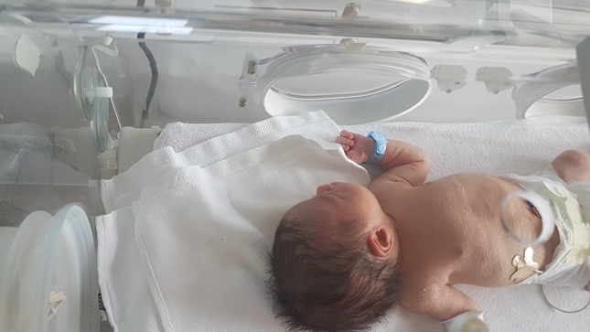

We are grateful for your prayer support.
We wish God’s blessings on your lives!
Yours faithfully,
Lajos and Evódia Budai
